REGIONAL PLANNING PANEL
(Hunter Central Coast)

Supplementary Planning Report

RPP No | 2017HCC027
DA Number | DA/1029/2017
Local Government Area | Central Coast Council
Proposed Development | 61 lot subdivision (56 small lot housing development, 2 x battle axe lots for the intent of 2 x dual occupancies), 3 residue lots, road construction and associated works in 2 stages
Street Address | 27-61 Nikko Road, Warnervale, Lot 1 DP.349727
Date lodged | 18 August 2017
Applicant | Kingston Property Fund No2 Pty Ltd
Architect: | Shaddock Architects
Number of Submissions: | 19 submissions (original DA)
Estimated value: | CIV $24,801,392
Regional Development Criteria | Capital investment value exceeding $20 million
List of All Relevant s4.15(1)(a) Matters | - State Environmental Planning Policy (State and Regional Development) 2011.  - State Environmental Planning Policy 55 – Remediation of Land  - State Environmental Planning Policy (Infrastructure) 2007  - State Environmental Planning Policy (Building Sustainability Index: BASIX) 2004  - State Environmental Planning Policy 44 – Koala Habitat Protection  - Wyong Local Environmental Plan 2013  - Wyong Shire Development Control Plan 2013  - Chapter 1.2 - Notification of Development Proposals  - Chapter 2.1 – Dwelling House and Ancillary Structures  - Chapter 2.3 – Dual Occupancy  - Chapter 2.11 - Parking and Access  - Chapter 3.1 Site Waste Management  - Chapter 3.6 – Tree and Vegetation Management  - Part 4 – Subdivision  - Chapter 6.5 – Warnervale South
List all documents submitted with this report for the panel’s consideration | Attachment 1 – Applicant’s amended plans and information  Attachment 2– Revised draft recommended conditions  Attachment 3- Previous Documents considered by the Panel (Council Assessment Report, Plans, Numerical Compliance Tables, and Draft recommended conditions)
Recommendation | Conditional Approval
Report by | Ross Edwards – Senior Development Planner

CENTRAL COAST COUNCIL

Development Assessment

Proposed 61 lot subdivision (56 small lot housing development, 2 x battle axe lots for the intent of 2 x dual occupancies), 3 residue lots, road construction and associated works in 2 stages
DA/1029/2017 Author: R Edwards

Summary

This supplementary report relates to Development Application No. DA/1029/2017 for a 61 lot subdivision (56 small lot housing development, 2 x battle axe lots for the intent of 2 x dual occupancies), 3 residue lots, road construction and associated works in 2 stages at 27-61 Nikko Road, Warnervale. The matter was initially considered (and deferred) by the Regional Planning Panel at its meeting of 27 November 2019.

Applicant Kingston Property Fund No2 Pty Ltd
Owner Kingston Property Fund No2 Pty Ltd
Application No DA/1029/2017
Description of Land 27-61 Nikko Road, Warnervale, Lot 1 DP.349727
Proposed Development Staged development – Stage 1: 61 lot subdivision which includes 56 small lots with associated dwellings and 2 battle-axe lots, 3 residue lots, road construction and associated works. Stage 2: Construction of a dual occupancy and Torrens title subdivision on two (2) of the battle-axe allotments (Lots 30 and 31 proposed under Stage 1 of the development).
Site Area 35.97ha
Zoning R2 – Low Density Residential
Value of Works $24,801,392

Recommendation

- That the additional information be considered in the Panel’s determination of the application.

- The Hunter and Central Coast Regional Planning Panel as consent authority grant consent to Development Application No 1029/2017 for a 61 lot subdivision (56 small lot housing development, 2 x dual occupancies), 3 residue lots, road construction and associated works in 2 stages on Lot: 1 DP: 349727, 27-61 Nikko Road, Warnervale subject to the conditions provided in attachment 2.

- That Council advise those who made written submissions of its decision.

- That those Government Authorities who made written submissions be notified of the Regional Planning Panel Decision.

Background

The development application was considered by the Regional Planning Panel at its meeting held Wednesday 27 November 2019.

The Planning Report recommended the following:

1 The Hunter and Central Coast Regional Planning Panel as consent authority grant Deferred Commencement consent to Development Application No 1029/2017 for a 61 lot subdivision (56 small lot housing development, 2 x dual occupancies), 3 residue lots, road construction and associated works in 2 stages on Lot: 1 DP: 349727, 27-61 Nikko Road, Warnervale subject to the conditions attached.

2. That Council advise those who made written submissions of the decision.

3. That Council advise those Government Authorities who made written submissions be notified of the Hunter and Central Coast Regional Planning Panel decision.

The Panel deferred a decision on the application pending the resolution of several issues as outlined in the minutes as reproduced below:

“The Panel determined to defer consideration of the development application to allow for the following to be addressed:

- The applicant is to undertake further consultation and discussion with AUSGRID and other adjoining land owners to obtain land owners consent for the proposed sewer line over their properties in order to provide greater certainty than an agreement will be obtained to ensure the proposed sewer line connection can be developed as proposed. The plans are to be updated to show the agreed sewer line alignment to enable Council to assess and such impacts;

- Council to consider seeking legal advice on the wording of any conditions relating to the proposed sewer line connection, and provide confirmation that the application meets owners’ consent requirements and provided certainty of the outcome;

- The applicant is to review in consultation with Council the provision of a neighbourhood park within the subject site, with appropriate amenity and inclusions provided to service the proposed new community and surrounding community with a different type of passive community open space than that provided within the nearby sportsground. The location, size and design of the neighbourhood park are to be shown on updated architectural and landscape plans.

- An addendum planning report is to be provide by the applicant that details the revisions outlined above, including but not limited to a description of the revised number of dwellings and lots to accommodate the neighbourhood park.

The decision was unanimous.”

In addition, the Panel requested that a further review be undertaken in relation to the potential contamination of the site, including a review of the draft conditions of consent relating to contamination with a particular emphasis on the timing of actions in relation to remediation and site audit, including addressing remediation of zinc and copper, as identified in the site contamination report.

Further Information and Applicant’s response

Following the deferral of the matted by the Panel, the applicant provided amended plans and a formal response to the Panel’s request for information as outlined in the minutes of the meeting (27 November 2019). This information was received by Council on 22 January 2020 and is provided in full as Attachment 1 for consideration by the Panel.

Location of Sewer

The sewer connection was initially proposed to be directed to the east through land held in the ownership of Ausgrid and connect into Council’s existing sewer infrastructure on Virginia Road. The applicant has altered the location of the proposed sewer line slightly to traverse the neighbouring site (15-19 Virginia Road). The revised location varies only slightly, but avoids the need for ongoing negotiation with Ausgrid (who were not receptive to having the sewer traverse their property).

Amended plans detailing the proposed sewer line through the adjoining site are provided in Attachment 1 for consideration by the Panel.

Owners consent from 15-19 Virginia Road, Warnervale was provided which grants consent for the proposed sewer line traversing through the land. This provides certainty that the development can be serviced in terms of sewer (which was a concern when initially considered by the Panel).

Council officers have reviewed the proposed sewer line through 15-19 Virginia Road Warnervale including the revised ecological reports. No concerns have been raised in relation to engineering or ecological impacts from the slight variation to the proposed sewer location. Suitable ecological and engineering conditions have been applied to the development as part of the draft conditions of consent to ensure any impacts on the environment are minimised. A copy of the draft conditions of consent are provided in Attachment 2 for consideration by the panel.

The Natural Resource and Access Regulator (NRAR) reviewed the proposed realignment of the sewer line as now proposed. NRAR has provided correspondence (dated 10 March 2020) advising that there are no required changes to the previously issued General Terms of Approval (GTA’s) granted on 8 May 2018. Those GTA’s remain applicable.

Neighbourhood Park

Chapter 6.5 of the Wyong Development Control Plan 2013 (WDCP 2013) provides for an optional ‘pocket park’ as part of the proposed development. The Panel, at its meeting held on Wednesday 27 November 2019, requested that Council officers discuss with the applicant the option of incorporating a pocket park/neighbourhood park as part of the proposed development.

Following the Panel meeting, discussions were held with (internal) Council stakeholder in relation to provision of the optional additional park as part of the proposed development (as identified in Figure 3 of Chapter 6.5 of the Wyong Development Control Plan 2013).

Based on Council’s draft Play Space Strategy, Council aims to provide a play space within 400m-800m walk from any house in urban areas. Council’s Open Space and Recreation Unit has confirmed that the optional/additional ‘pocket park’ within the development would not be supported in this circumstance, as the proposed development site is located within 400m-800m of two existing play spaces being:

- The existing park/playground on the corner of Nikko Road and Warnervale Road (approx. 400 metres from the site),

The existing park on the corner of Nikko Road and Warnervale Road has been recently renovated with updated play equipment and soft fall surfacing (se images below); and

- Warnervale Oval on the corner of Warnervale Road and Virginia Road (100 metres from the subject site, with future pedestrian connections to be established).

Council is currently completing designs for the redevelopment of Warnervale Oval for re-development into a larger recreation area to meet the needs of the increasing residential population in the Warnervale area.

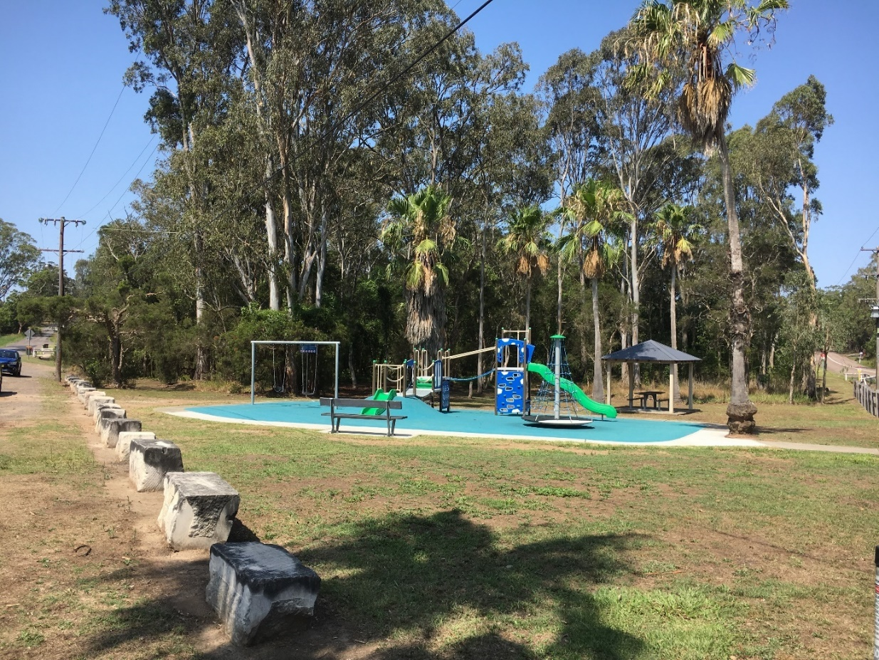
Public playground on the corner of Nikko Road and Warnervale Road

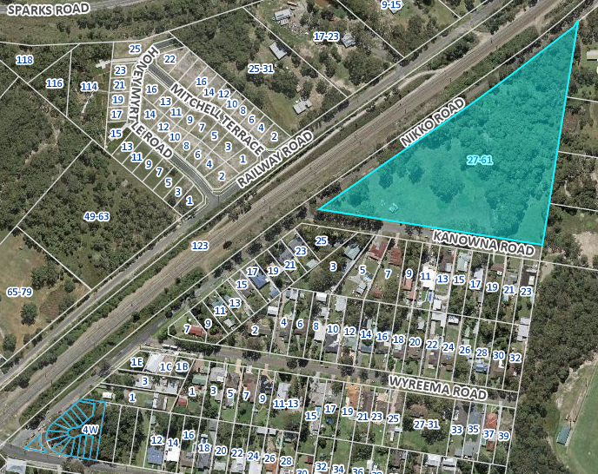
Aerial photograph indicating in blue the existing play park from proposed development

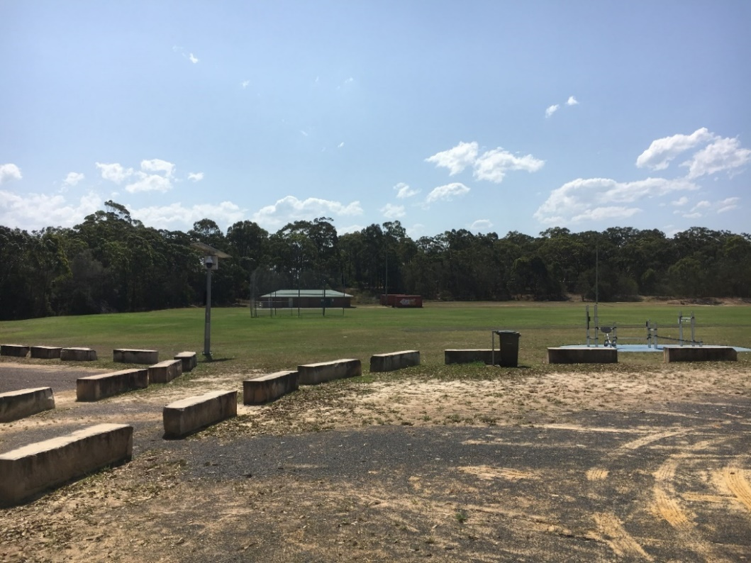
Public park/sports oval on the corner of Warnervale Road and Virginia Road

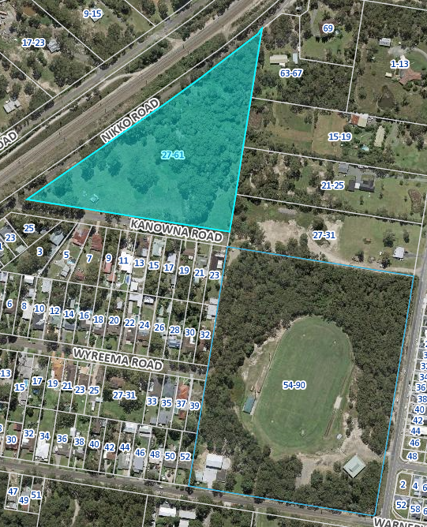
Aerial photograph indicating in blue the existing park from the proposed development

Council’s Open Space and Recreation Unit have further confirmed that the ongoing maintenance of an additional Council asset (park) in the area will result in an increase in unnecessary costs to Council and ratepayers which is not in the public interest – especially considering that there are a range of facilities within near proximity.

Furthermore, the optional additional park as identified in Figure 3 of Chapter 6.5 of the Wyong Development Control Plan 2013 (WDCP 2013) is not identified under the Warnervale Contributions Plan to be provided or dedicated to Council.

The additional ‘pocket park’ within the development site is deemed not necessary to provide amenity for the future residents within the development. In this regard, the proposed future dwellings within the site are compliant with the required setback, POS and solar access requirements under Chapters 2.1 and 2.3 of the WDCP 2013. It is noted that the proposed size and location of the private open space areas associated with the dwellings comply with the requirements of Chapters 2.1 and 2.3 of the WDCP 2013 which is a minimum of 24m² for dwellings and 45m² for dual occupancies.

The existing open space/park areas located within the broader vicinity of the site, in combination with the internal amenity afforded to residents within the development is considered to provide a suitable level of amenity. On this basis, Council did not consider it warranted to pursue the optional additional park to be provided as part of the overall development.

Neighbour Notification

The proposed lot layout, dwellings, road layout and associated works within the development site were not altered to what was originally presented to the Regional Planning Panel for consideration on 27 November 2019. The only change to the proposed development is the minor re-location of the proposed sewer line through the adjoining site of 15-19 Virginia Road, Warnervale.

Council officers are of the view that the proposed redirection of the sewer line through the adjoining site of 15-19 Virginia Road is of a minor nature and will not result in any additional impacts than what was originally proposed. Therefore, the amended application was not required to be re-notified in accordance with Clause 2.10 (c) of Chapter 1.2 of the WDCP 2013.

Contamination

The draft contamination conditions of consent have been revised and updated in relation to the timing of the remediation and site audit occurring which includes the remediation of zinc and copper, as identified in the provided site contamination report.

The development has been appropriately conditioned so that the site remediation works are undertaken during the subdivision works and the subdivision certificate cannot be released until a site audit has been issued verifying that the site has been suitably remediated to a level which is suitable for residential development.

In addition, it is conditioned that a construction certificate cannot be issued for the construction of the proposed dwellings until the Subdivision Certificate has been released and the lots registered.

The draft conditions of consent are provided in Attachment 2 for consideration by the Panel.

Conclusion

Additional information has been provided by Council and the applicant to address the matters raised in the Regional Planning Panel meeting of 27 November 2019.

The proposal is recommended for approval subject to conditions.

Attachments
Attachment 1 | Amended plans and information submitted by Applicant
Attachment 2 | Revised draft recommended conditions
Attachment 3 | Previous Documents considered by the Panel (Council Assessment Report, Plans, Numerical Compliance Tables, and Draft recommended conditions)

Attachment 2 | Revised Conditions of Consent

1. PARAMETERS OF THIS CONSENT

1.1. Implement the development substantially in accordance with the plans and supporting documents listed below as submitted by the applicant and to which is affixed a Council stamp "Development Consent" unless modified by any following condition.

Architectural Plans by: Shaddock Architects
Subdivision Plans by: Daly Smith
Landscape plan by: Moir Landscape Architects
Civil DA Stormwater Plans by: Daly Smith

Description | Sheets | Issue | Date
Drawing schedule and Site Analysis Plan | A01  1 of 28 | 28 | 12/09/2019
Site plan – Stage 1 | A02  2 of 28 | 28 | 12/09/2019
Site Plan – Stage 2 | A03  3 of 28 | 28 | 12/09/2019
Part Site Plan 1 | A04  4 of 28 | 28 | 12/09/2019
Part Site Plan 2 | A05  5 of 28 | 28 | 12/09/2019
Part Site Plan 3 | A06  6 of 28 | 28 | 12/09/2019
Part Site Plan 4 | A07  7 of 28 | 28 | 12/09/2019
Part Site Plan 5 | A08  8 of 28 | 28 | 12/09/2019
DT1 – Dwelling Type 1  Typical plan and elevations | A09  9 of 28 | 28 | 12/09/2019
DT2 – Dwelling Type 2  Typical plans and elevations | A10  10 of 28 | 28 | 12/09/2019
DT3 – Dwelling Type 3  Typical plans and elevations | A11  11 of 28 | 28 | 12/09/2019
DT4 – Dwelling Type 4  Typical plans and elevations | A12  12 of 28 | 28 | 12/09/2019
DT5 – Dwelling Type 5  Typical plans and elevations | A13  13 of 28 | 28 | 12/09/2019
DT6 – Dwelling Type 6  Typical plans and elevations | A14  14 of 28 | 28 | 12/09/2019
DT7 – Dwelling Type 7  Typical plans and elevations | A15  15 of 28 | 28 | 12/09/2019
DT8 – Dwelling Type 8  Typical plans and elevations | A16  16 of 28 | 28 | 12/09/2019
DT9 – Dwelling Type 9  Typical plans and elevations | A17  17 of 28 | 28 | 12/09/2019
DT10 – Dwelling Type 10  Typical plans and elevations | A18  18 of 28 | 28 | 12/09/2019
DT11 – Dwelling Type 11  Typical plans and details | A19  19 of 28 | 28 | 12/09/2019
DT12 – Dwelling Type 12  Typical plans and details | A20  20 of 28 | 28 | 12/09/2019
DT13 – Dwelling Type 13  Typical plans and details | A21  21 of 28 | 28 | 12/09/2019
DT14 – Dwelling Type 14  Typical plans and details | A22  22 of 28 | 28 | 12/09/2019
DT15 – Dwelling Type 15  Typical plans and details | A23  23 of 28 | 28 | 12/09/2019
DT16 – Dwelling Type 16  Typical plans and elevations | A24  24 of 28 | 28 | 12/09/2019
DT17 – Dwelling Type 17  Typical plans and elevations | A25  25 of 28 | 28 | 12/09/2019
Streetscape Elevations 1 | A26  26 of 28 | 28 | 12/09/2019
Streetscape Elevations 2 | A27  27 of 28 | 28 | 12/09/2019
Streetscape Elevations 3 | A28  28 of 28 | 28 | 12/09/2019
Proposed Subdivision Plan - Stage 1 | 01 | G | 13/09/2019
Proposed Subdivision Plan – Stage 2 | 02 | G | 13/09/2019
Landscape Plan - Cover Sheet | LP01 | B | 20/05/2019
Landscape Plan – Site Analysis | LP02 | B | 20/05/2019
Landscape Plan – Site Photography | LP03 | B | 20/05/2019
Landscape Masterplan | LP04 | B | 20/05/2019
Landscape Concept Plan | LP05 | B | 20/05/2019
Landscape Concept Plan | LP06 | B | 20/05/2019
Landscape Concept Plan | LP07 | B | 20/05/2019
Landscape Concept Plan | LP08 | B | 20/05/2019
Landscape Detail Plan | LP09 | B | 20/05/2019
Landscape Detail Plan | LP10 | B | 20/05/2019
Elevations | LP11 | B | 20/05/2019
Elevations/Sections | LP12 | B | 20/05/2019
Planting Schedule | LP13 | B | 20/05/2019
Details | LP14 | B | 20/05/2019
Specification/details | LP15 | B | 20/05/2019
Civil Works Cover Sheet and Drawing Schedule | C01 | E | 12/09/2019
Site Plan | C02 | E | 12/09/2019
Erosion and Sediment Control Plan | C03 | E | 12/09/2019
Site regrading plan | C04 | E | 12/09/2019
Typical Sections and Details | C05 | E | 12/09/2019
Typical Sections and Details – Part 2 | C06 | E | 12/09/2019
Road CL Profiles – Road 1-3 | C07 | E | 12/09/2019
Road CL Profiles – Road 4 | C08 | E | 12/09/2019
Catchment Plan | C09 | E | 12/09/2019
Stormwater Drainage Plan | C10 | E | 12/09/2019
Sewer and Water Plan | C11 | F | 17/03/2020

Supporting Documentation

Document | Prepared By | Date
Statement of Environmental Effects | Shaddock Architects | September 2019
Waste Management Plan | Shaddock Architects | 10/06/16
Traffic Impact Assessment | Intersect Traffic | May 2019
Noise Impact Assessment | Global Acoustics | 17 August 2017
Preliminary Site Investigation for Contamination | Qualtest Laboratory (NSW) Pty Ltd | 19 July 2017
Flora and Fauna Assessments | Enviro Ecology | 07/08/2017  13/10/2017  05/03/2018  21/03/2018  11/06/2018  30/07/2018  12/09/2019  19/01/2020
Vegetation Management Plan | Enviro Ecology | 27/02/2018
Railway Level Crossing Impact Report | Intersect Traffic | 21 May 2018
Retaining wall Sketches | Shaddock Architects | 11 September 2019
Amended Solar Access Report | Shaddock Architects | September 2019

1.2. Carry out all building works in accordance with the Building Code of Australia.

1.3. Comply with the General Terms of Approval / requirements from the Authorities as listed below and attached as a schedule of this consent.

Government Agency / Department / Authority | Description | Ref No | Date
NSW RFS | Bush Fire Safety Authority | D17/3153 | 25 June 2019
Natural Resource Access Regulator (Formerly Department of Primary Industries) | General Terms of Approval | IDAS1102700 | 08 May 2018

1.4 The development being carried out in two (2) stages being:

Stage 1 - 61 lot subdivision which includes 56 small lots with associated dwellings, 2 x battle-axe lots, 3 residue lots, road construction and associated works.

Stage 2 - The construction of a dual occupancy and Torrens title subdivision on two (2) of the battle-axe allotments (Lot 30 and 31 proposed under Stage 1 of the development).

Note: All conditions to apply to all stages unless otherwise specified.

1.5. Comply with all commitments listed in BASIX Certificate as required under clause 97A of the Environmental Planning and Assessment Regulation 2000.

1.6. A Construction Certificate is to be issued by the Principal Certifying Authority prior to commencement of any construction works. The application for this Certificate is to satisfy all of the requirements of the Environmental Planning and Assessment Regulation 2000.

1.7. An application for a Subdivision Certificate must be submitted to and approved by the Council/Certifying Authority prior to endorsement of the plan of subdivision.

1.8. Prior to the occupation or use of the building/structure, an application for an Occupation Certificate for the development must be submitted to and approved by the Principal Certifying Authority.

1.9. Where conditions of this consent require approval from Council under the Roads Act 1993, Local Government Act 1993 or Water Management Act 2000, a completed Subdivision Construction Certificate application form must be lodged with Council and be accompanied by detailed design drawings and supporting information. Upon submission to Council, fees and charges will be calculated in accordance with Council’s Management Plan. The fees and charges must be paid prior to Council commencing the design assessment.

2. PRIOR TO ISSUE OF ANY CONSTRUCTION CERTIFICATE

2.1. All conditions under this section must be met prior to the issue of any Construction Certificate.

2.2. Prior to the issue of any Construction Certificate for the dwellings, the subdivision of the lots must be registered with New South Wales Land Registry Services.

2.3. Prior to the issue of any Construction Certificate for the dwellings a Validation and Site Monitoring Report in accordance with the NSW EPA Managing Land Contamination – Planning Guidelines SEPP 55 – Remediation of Land (1998) is to be approved by Council’s Environmental Health Officer. The investigation must be prepared by a suitably qualified contaminated land professional which verifies that the site has been remediated from contamination which includes zinc and copper and is suitable for residential development.

2.4. The submission to the Accredited Certifier of a detailed stormwater management plan featuring:
- The road hierarchy is to be in accordance with Council’s DCP 2013 Chapter 6.5 Warnervale South. The Road widths are to be the following
  - Nikko Road (4.5m – 7.9m – 4.5m) Type 4
  - Kanowna Road (4.5m – 10.4m – 5.5m) Type 5
  - All other roads (4.5m – 7.9m – 4.5m) Type 4.
- The future Road on the northern side of the water course is to be constructed with stage 1.

- Kerb and guttering for the full street frontage of Nikko and Kanowna Road frontages.

- Infill road pavement construction (up to half road) adjoining the proposed kerb and guttering for Nikko and Kanowna Roads.

- Re-alignment of the intersection of Kanwna Road and Nikko Road intersection to improve the entry angle in accordance with the Austroads guidelines. This may include road widening to maintain a 4.5m wide verge.

- Street stormwater drainage systems in accordance with Council’s Civil Design Guidelines.

- Onsite Detention System (OSD) to pre-development flow rates for the full range of rain events.

- Provision of Gross Pollutant Traps (GPTs) to drainage outlets.

- Drainage modelling of the redefined water course with particular attention to the entry of flows from Nikko Road and the impact to Nikko Road. This may require the augmentation of the existing piped system subject to modelling results.
- Concrete footpaths 1.5 metres wide for the development are to be provided in accordance with Council’s DCP 2013 Chapter 6.5 Warnervale South.

- Pavement marking & signage.

- Pavement design catering for 2*10^6 equivalent standard axles.

- Vehicle access crossing(s) to Nikko and Kanowna Roads.

- Any associated works to ensure satisfactory transitions to existing infrastructure

- The submission to Council as the Roads Authority of street lighting and reticulation design drawings. The design shall be prepared in accordance with AS/NZS 1158 and AS 4282-1997, including the provision of current best practice energy efficient lighting, documentation confirming a minimum of twenty (20) year design life and be approved by the Council as the Roads Authority prior to issue of a Construction Certificate.
The plans must be prepared in accordance with AS/NZS3500.3:2004 and Council's Civil Works Specification Design Guidelines 2018, and be approved by the Accredited Certifier prior to issue of the Construction Certificate.

2.5. Applications for a vehicle access crossing on existing Public Roads are to be lodged with Council, the application fee paid and the application approved prior to issue of a Construction Certificate.

2.6. The construction of a driveway for the full length of the accessway of the battle axe lot in accordance with Council's Civil Works Design Guidelines. The design drawings must be approved by the Accredited Certifier prior to the issue of a Construction Certificate.

2.7. Submit to Council as the Roads Authority a Detailed Design stage Road Safety Audit prepared by an Audit team of a minimum Level 3 and Level 2 Road Safety Auditor registered on the NSW Register of Road Safety Auditors. No recommendations are to be made in the Road Safety Audit to address any identified deficiencies. Resolutions of the identified deficiencies are to be carried out in consultation with Council with sign off of the corrective actions by Council prior to approval of the detail design. This is to improve the safety outcomes of the proposal. Any deficiencies identified within the audit must be resolved in consultation with Council prior to the approval of design drawings.

2.8. The developer must submit an application to Council under Section 305 of the Water Management Act 2000 for any requirements for the obtaining of a Section 307 Certificate of Compliance. The application must be made prior to the issue of the Construction Certificate. Note: The Section 305 Notice may contain requirements associated with the development that must be completed prior to the issue of the Construction Certificate.

2.9. Prior to the commencement of detailed design works within any public road, contact should be made with the National Community Service “Dial before you Dig” regarding the location of underground services in order to prevent injury, personal liability and even death. Enquiries should provide the property details and the nearest cross street/road.

2.10. The submission to Council of the proposed road names. The names must be approved by Council as the Roads Authority prior to issue of a Construction Certificate.

2.11. An Unexpected Finds Management Plan must be developed and implemented prior to the issue of any Construction Certificate for the discovery of any asbestos fragments, or any other unexpected contamination during any future construction works at the site.

2.12. Prior to the issuing of a Construction Certificate for the subdivision works approved under this consent, submit to Council, and have approved by Council’s Environmental Health Officer, a Remediation Action Plan in accordance with the NSW Environment Protection Authority Managing Land Contamination – Planning Guidelines SEPP 55 – Remediation of Land (1998). The investigation must be prepared by a suitably qualified contaminated land professional and must set objectives and document the process to remediate the site.

2.13. In accordance with the Department of Planning and Environment (DP&E) document “Development Near Rail Corridors and Busy Roads – Interim Guideline” (2008), Category 2 construction standards are to be applied to Lots, 1 to 5, 23 to 27, 301, 302, 311, 312, 39 to 41, 421, 422, 43 to 47, 481, 482, 491, 492, 50, 51, 521, 522.

2.14. In accordance with the Department of Planning and Environment (DP&E) document “Development Near Rail Corridors and Busy Roads – Interim Guideline” (2008), Category 1 construction standards are to be applied to Lots 6 to 14, 151, 152, 161, 162, 17 to 22, 28, 29, 32 to 34, 361, 362, 37 and 38.

2.14. Prior to the issue of any Construction Certificate, the E2 zoned Environmental 5Corridor land and trees and native vegetation proposed for retention must be clearly identified on all final engineering and landscaping plans. The western road reserve of Nikko Road must be marked as a No Go Area on all plans. All fenced tree and vegetation protection areas must be clearly marked as "No Go Area" on all plans.

2.16. The detailed design and landscaping plans for the detention basin is to incorporate features to increase habitat value for native fauna, including frogs and wading birds as outlined in the Conservation Management Plan for Precinct 7A” Umwelt, February 2014. The design features will be based on advice from an Ecologist and will include engineered features, habitat enhancement features, revegetation, promotion of growth of native fringing vegetation, monitoring of water quality, weed removal and monitoring for the presence of predatory Eastern mosquitofish (Gambusia holbrooki). The detailed design and landscaping plans for the basin are to be approved by Council’s Ecologist prior to release of any construction certificate.

2.17. The provision of an amended landscape plan which incorporates the requirements of the required vegetation management plan. The amended landscape plan is to be approved by Council’s Landscape Architect.

3. PRIOR TO COMMENCEMENT OF ANY WORKS

3.1. All conditions under this section must be met prior to the commencement of any works.

3.2. No activity is to be carried out on-site until the Construction Certificate has been issued, other than:

- Site investigation for the preparation of the construction, and / or
- Implementation of environmental protection measures, such as erosion control and the like that are required by this consent
- Demolition approved by this consent.

3.3. Appoint a Principal Certifying Authority for the building work:

- The Principal Certifying Authority (if not Council) is to notify Council of their appointment and notify the person having the benefit of the development consent of any critical stage inspections and other inspections that are to be carried out in respect of the building work no later than two (2) days before the building work commences.
- Submit to Council a Notice of Commencement of Building Works or Notice of Commencement of Subdivision Works form giving at least two (2) days’ notice of the intention to commence building or subdivision work. The forms can be found on Council’s website: www.centralcoast.nsw.gov.au

3.4. Erect a sign in a prominent position on any work site on which building, subdivision or demolition work is being carried out. The sign must indicate:

- The name, address and telephone number of the Principal Certifying Authority for the work; and
- The name of the principal contractor and a telephone number at which that person can be contacted outside of working hours; and
- That unauthorised entry to the work site is prohibited.
- Remove the sign when the work has been completed.

3.5. A temporary hoarding or temporary construction site fence must be erected between the work site and adjoining lands before the works begin and must be kept in place until after the completion of the works if the works:

- could cause a danger, obstruction or inconvenience to pedestrian or vehicular traffic;

- could cause damage to adjoining lands by falling objects; or

- involve the enclosure of a public place or part of a public place.

These works are specified as exempt development within the State Environmental Planning Policy (Exempt and Complying Development Codes) 2008 – where the development standards are prescribed in Clause 2.110.
3.6. Prior to the commencement of construction an initial Erosion and Sediment Control Plan (ESCP) prepared in accordance with the latest edition of the Landcom Publication ‘Soils and Constructions- Volume 1’ (The Blue Book) shall be provided to the Principal Certifying Authority. This plan shall be modified and updated during construction to reflect any changes due to the on-ground/site conditions. A copy of any modifications or updates to the ESCP shall be provided to the PCA and provided to Council upon request.

Erosion and sediment controls shall be monitored, maintained and adapted in accordance with the most recent ESCP until the site is fully stabilised and landscaped. Failure to comply with this condition may result in fines under the provision of the Protection of the Environment Operations Act 1997.

3.7. Prior to commencing any works upon public roads the developer and their contractor will be required to:
- Obtain a copy of the Council approved Civil Works plans and pavement design (if applicable).
- Obtain a copy of Council’s Civil Works Specification Construction Guidelines 2018. This is Council’s Specification for Civil Works and is available on Council’s web site.
- Arrange a meeting on-site with Council’s Principal Development Construction Engineer on 1300463954.

3.8. Prior to works associated with development commencing, a dilapidation report must be prepared and submitted to Council as the Roads Authority. The required dilapidation report must document and provide photographs that clearly depict any existing damage to the road, kerb, gutter, footpath, driveways, water supply, sewer works, street trees, street signs or any other Council assets in the vicinity of the development. Note: The report will be used by Council to determine the extent of damage arising from site and construction works.

3.9. Prior to works associated with the development commencing, a Plan of Management is to be submitted to and approved by Council as the Roads Authority for any works or deliveries that impact on any public roads or public land as a result of the construction of the development. The plan must include a Traffic Control Plan prepared by a person holding Roads and Maritime Service Authority (RMS) accreditation for selecting and modifying traffic control plans. Fees and charges are applicable to the review and approval of the required management plan in accordance with Council’s Plan of Management.

3.10. Prior to works associated with the development commencing, a Construction and Environment Management Plan (CEMP) is to be submitted to and approved by the Principal Certifying Authority. The required CEMP must outline the sequence and construction methodology, and specify mitigating measures to ensure all works are carried out with minimal environmental impact in relation to project staging, waste management, traffic management and environmental management.

3.11. Prior to the commencement of any works, the Applicant shall prepare a Construction Traffic Management Plan for the development. The plan shall include Traffic Control Plans prepared by a suitably qualified and experienced consultant. All works must ensure the safety of all vehicles and pedestrians within the frontage service road.

3.12. Implement all the recommendations specified in the contamination report titled ““Proposed Residential Subdivision Preliminary Contamination Assessment, 27-61 Nikko Road Warnervale” dated 19 July 2017 project ref:NEW17P-0106-AA.

3.13. Submit a Wildlife Management Plan (WMP) to Council’s Ecologist for approval. The WMP must be approved by Council’s Ecologist prior to any clearing, earthworks or construction works. The WMP must be prepared in accordance with the “Central Coast Council Flora and Fauna Guidelines 2019”. The WMP must provide details of how mitigation against native animal welfare issues will be achieved and must include the following:

- There are additional hollow bearing trees within the development area that were not included in the Flora and Fauna Assessment. Hollow bearing tree survey and mapping is to be revised and included in the WMP. Details provided are to include location of trees, number and size of hollows, aspect of hollow and height.

- A revised hollow salvage/replacement strategy based on the revised hollow tree survey. This is to provide minimum 1:1 replacement of hollows and is to prioritise use of salvaged hollows and creation of artificial hollows in living trees by an Arborist (see Rueegger 2017) over use of nest boxes. Details are to include likely number of salvaged hollows, suitable trees for creation of hollows, nest boxes (number, type, thermal insulation, thickness), location, installation methods and the recommended monitoring/maintenance program. The final number of nest boxes to be installed will need to be calculated once the number of salvaged hollows is determined. Hollows/boxes must be installed across a sufficient area so as not to exceed natural hollow densities for target species.

- Identify fauna likely to occur on-site and advise on management actions to avoid and/or mitigate the risk of harm to the welfare of native animals including avoiding breeding times for species present.

- Identify on a plan and physically mark habitat trees.

- Identify on a plan and physically mark other habitat resources for salvage (eg. very large or significant tree hollows, hollow logs and boulders) and specify where the salvage materials are to be permanently placed or temporarily stored.

- Tree felling procedures are to be as per the “Conservation Management Plan for Precinct 7A” Umwelt, February 2014. Provide timeframe/schedules and protocols for clearing of non-habitat trees, and then habitat trees. The protocols for clearing of habitat trees are to identify the most benign method of dislodging fauna and felling trees and are to include visual inspection, measures to encourage fauna to leave prior to felling, relocation of fauna/tree felling while the fauna remains in-situ, and treatment of captured fauna.

- Identify nearby release areas for animals requiring immediate relocation (this may include a recommendation to install nest boxes in adjacent habitat prior to clearing as temporary refuge for displaced animals). Contact details for the nearest vet are to be included. Ensure appropriate permissions have been granted to enter third party properties if the animals are to be released offsite.

3.14. Supervision by a suitably qualified Project Ecologist is required for all pre-works conditions. The western road reserve of Nikko Road is a No Go Area. No vegetation or soil is to be disturbed in this area due to the presence of threatened orchids. All vegetation must be protected by a minimum three strand wire fence with parrawebbing erected on the edge of the bitumen and running north from Nikko Road for the length of the development site. The fence is to be erected from the road in a manner to ensure no groundcover is disturbed. The Ecologist must directly supervise the erection of the fencing. The Ecologist must certify to Council’s Ecologists the erection of fencing prior to commencement of any works on the site. The fence is to be clearly marked as a "No Go Area" on the fencing itself. No clearing of vegetation, parking of vehicles or machinery, stockpiling, materials storage or unauthorised access is to occur within the fenced conservation area. The fence is to be regularly checked and maintained for the period of all construction works.

3.15. Erect a permanent minimum two (2) metre high chain wire link security fence along the boundary of the E2 zoned Environmental Corridor. A lockable access gate must be provided for maintenance purposes. The fence will not be constructed of wires utilising barbs. The fence must be sign posted as an environmental protection area at intervals of no less than thirty (30) metres to identify the conservation value of the land and discourage inappropriate uses. Wording and design of signage is to be approved by Council’s Natural Assets Unit prior to manufacture.

3.16. Prior to works associated with the development commencing, all trees and vegetation nominated for retention are to be suitably protected by fencing or other accepted protection method in accordance with AS/NZS 4970-2009 - Protection of Trees on Development Sites. All required tree and vegetation protection measures are to be maintained for the duration of construction works.

3.17 Conduct all pre-development works outlined in the Wildlife Management Plan approved under Condition 3.13 of this consent and the Vegetation Management Plan prepared by Enviro Ecology dated February 2018.

4. DURING WORKS

4.1. All conditions under this section must be met during works.

4.2. Carry out construction or demolition works during the construction phase of the development only between the hours as follows:

7.00am and 5.00pm Monday to Saturday

No construction or demolition works associated with the development are permitted to be carried out at any time on a Sunday or a public holiday.

4.3. During the construction phase of the development, if any Aboriginal object (including evidence of habitation or remains), is discovered during the course of the work:

- All excavation or disturbance of the area must stop immediately in that area, and
- The Office of Environment and Heritage must be advised of the discovery in accordance with section 89A of the National Parks and Wildlife Act 1974.

Note: If an Aboriginal object is discovered, an Aboriginal heritage impact permit may be required under the National Parks and Wildlife Act 1974.

4.4 Prior to commencement of construction or site works, a Soil and Water Management Plan (SWMP) prepared in accordance with the latest edition of the Landcom Publication “Managing Urban Stormwater: Soils and Construction – Volume 1” (the Blue Book). Sediment control fencing must remain in place until such time as the site is landscaped or turf is established.

Note: Discharge of sediment from a site may be determined to be a pollution event under provisions of the Protection of the Environment Operations Act 1997. Enforcement action may commence where sediment movement produces a pollution event.

4.5. Keep a copy of the stamped approved plans on-site for the duration of site works and make the plans available upon request to either the Principal Certifying Authority or an officer of Council.

4.6. Do not give rise to offensive noise as defined in the Protection of the Environment Operations Act 1997.

4.7. Do not give rise to water pollution as defined in the Protection of the Environment Operation Act 1997.

4.8. The developer is solely responsible for any costs relating to alterations and extensions of existing roads, drainage, water and sewer infrastructure and other utilities for the proposed development.

4.9. Other public authorities may have separate requirements and should be consulted prior to commencement of works in the following respects:

- Australia Post for the positioning and dimensions of mail boxes in new commercial and residential developments;
- AGL Sydney Limited for any change or alteration to gas line infrastructure;
- Ausgrid for any change or alteration to electricity infrastructure or encroachment within transmission line easements;

- Telstra, Optus or other telecommunication carriers for access to their telecommunications infrastructure.

4.10. During the construction phase of the development, all building materials, plant and equipment must be placed on the site of the development in order to ensure that pedestrian and vehicular access within adjoining public roads, footpaths and reserve areas, is not restricted and to prevent damage to public infrastructure.

4.11. Suitable dust suppression measures shall be implemented and maintained by the developer during demolition, excavation and construction works associated with the development. Such measures are required to minimise the emission of dust and other impurities into the surrounding environment.

4.12. All materials other than fill imported to the site for civil works, shall have a resource recovery exemption made under the Protection of the Environment Operations (Waste) Regulation 2005.

4.13. All site fill material shall be classified as Virgin Excavated Natural Material (VENM) or Excavated Natural Earth (ENM) in accordance with the Waste Classification Guidelines – Part 1: Classifying Waste published by the Department of Environment, Climate Change and Water NSW (now Office of Environment and Heritage). Site fill material shall be certified as VENM or ENM by a practising Geotechnical Engineer prior to haulage to site. Certification documentation shall be provided to the Principal Certifying Authority throughout the construction phase of the works.

4.14. During construction, all fenced conservation areas are to be clearly marked as a "No Go Area" on the fencing itself. No clearing of vegetation, storage of vehicles or machinery, stockpiling, materials storage or unauthorised access is to occur within the fenced areas.

4.15. Supervision by a suitably qualified Project Ecologist is required for all vegetation clearing works. The Ecologist must:

- Implement the approved Wildlife Management Plan and Vegetation Management Plan
- Mark trees for retention and removal
- Supervise the installation of fencing around the Environmental Corridor, No Go Area along Nikko Road and any other trees to be retained
- Provide an environmental induction to civil contractors and subcontractors, including No Go Areas
- Undertake pre clearing surveys
- Directly supervise all vegetation clearing and removal of habitat trees. Hollow bearing trees are to be sectionally dismantled by an Arborist under supervision of the Ecologist and suitable hollows salvaged for reattachment to trees in the environmental corridor.

The Project Ecologist must provide updates in writing to Council’s Ecologist within ten business days after completion of the above environmental protection measures.

4.16. Conduct all clearing works in accordance with the Wildlife Management Plan approved under Condition 3.13 and the Vegetation Management Plan prepared by Enviro Ecology dated February 2018.

4.17. Supply any plant stock used in landscaping from provenance specific seed/material collected from locally endemic species to maintain genetic diversity as per the requirements of the Vegetation Management Plan (Enviro Ecology, February 2018). Non-provenance specific material is prohibited.

4.18. Vehicles and other equipment to be used on site must be completely free of soil, seeds and plant material before entering/leaving the site to prevent the spread of exotic plant species and pathogens. All vehicles and machinery must be inspected prior to site entry and those failing inspection should be cleaned. Appropriate records of inspections shall be maintained.

4.19. Utilise timber from felled native trees by:

- Re-instating logs as ground habitat in the E2 land to the north of the site, under the supervision of the project Ecologist and in consultation with Council, and/or

- Wood chip or tub grind into mulch for landscaping or soil stabilisation; and/or

- Recycling for use in construction materials, furniture or fencing.

4.20. Immediately notify Council of any new information which comes to light during remediation, demolition or construction works which has the potential to alter previous conclusions about site contamination and remediation.

5. PRIOR TO ISSUE OF ANY SUBDIVISION CERTIFICATE

5.1. All conditions under this section must be met prior to the issue of any Subdivision Certificate.

5.2 Pay developer contributions to Council as calculated in the formula below:

Developer contribution = $2,335,427.07 X Current CPI ÷ Base CPI

where “Current CPI” is the Consumer Price Index (All Groups Index) for Sydney as published by the Australian Statistician at the time of payment of developer contributions pursuant to this condition, and “Base CPI” is the Consumer Price Index (All Groups Index) for Sydney as published by the Australian Statistician at the date of this consent.

This condition is imposed pursuant to Section 7.11 or 7.12 of the Environmental Planning and Assessment Act 1979.

Note: Any works required for the development that are also identified in the relevant Contributions Plan may be subject to a credit in accordance with that Plan. Any request for a credit for works to be carried out in accordance with the Plan must be requested and agreed to by Council via a Works-in-Kind Agreement prior to the commencement of any works.

5.3. Prior to the issue of a Subdivision Certificate, any damage not shown in the Dilapidation Report submitted to and approved by the Principal Certifying Authority prior to site works commencing, will be assumed to have been caused as a result of the site works undertaken with respect to the development and must be rectified at the applicant’s expense.

5.4. Prior to the issue of a Subdivision Certificate, suitable certification prepared by a Registered Surveyor certifying that all lots have been filled to a minimum 600mm above (Warnervale/Wadalba) the 1% AEP flood level, is to be provided for the approval of the Accredited Certifier.

5.5. Prior to the issue of a Subdivision Certificate, suitable lighting to P4 shall be provided in accordance with the requirements of AS/NZS 1158 and AS/NZS 2890.1.

5.6. All road signage and pavement marking works must be completed in accordance with the plans approved by the Local Traffic Committee and approved by Council as the Roads Authority prior to the issue of the Subdivision Certificate.

5.7. The provision of any additional civil works required to ensure satisfactory transitions to existing work as a result of work conditioned for the development works are to be approved by Council as the Roads Authority prior to issue of the Subdivision Certificate.

5.8. All works within the public road must be completed in accordance with the approved Civil Works design drawings and Council’s Civil Works Construction Specification and be approved by Council as the Roads Authority prior to the issue of the Subdivision Certificate.

5.9. The submission to the Council as the Roads Authority of a ‘pre-opening stage’ Road Safety Audit prepared by a Level 3 Road Safety Auditor recognised on the NSW Register of Road Safety Auditors. Any deficiencies identified within the audit must be resolved in consultation with Council prior to the approval of the works.

5.10. The dedication of road widening at the intersection of Kanowna and Nikko Roads to Council.

5.11. The submission of details to demonstrate the completion of all works required under Development Consent No DA/1029/2017 prior to issue of the Subdivision Certificate.

5.12. The certification by a Registered Surveyor, prior to issue of a Subdivision Certificate that all construction has been effected within the appropriate property, easement boundaries and rights of carriageway. The certification shall be accompanied by a copy of the final subdivision or easement plan, with the distances from the boundaries to the edges of these structures endorsed in red thereon and signed by the surveyor.

5.13. The provision of a report to Council by a Geotechnical Engineer classifying each lot being created in accordance with AS 2870-2011 - Residential Slabs and Footings, prior to issue of a Subdivision Certificate.

5.14. The provision of Works as Executed information as identified in Council's Civil Works Construction Specification prior to issue of the Subdivision Certificate. The information is to be submitted in hard copy and this information is to be approved by Council prior to issue of the Subdivision Certificate.

5.15. Prior to issue of a Subdivision Certificate the provision of written confirmation from the relevant service authorities that satisfactory arrangements have been made for the provision of the following services to each lot:

- telecommunications
- electricity supply
- gas supply
- national broadband network
- water supply
- sewerage

The location of services must be shown on a copy of the final subdivision plan, with the distances from the boundaries to each service endorsed in red thereon.

5.16 All subdivision works must be approved by Council prior to the issue of a Subdivision Certificate.

5.17. The plan of subdivision and Section 88B instrument shall establish the following title encumbrances with Council being nominated as the sole authority to release, vary or modify each encumbrance unless specifically noted otherwise. Wherever possible the extent of the land affected shall be defined by bearings and distances shown on the plan of subdivision:

- ‘Right of Carriageway’ as identified on the approved development plans.

- ‘Easement to Drain Water’ as identified on the approved development plans.

- ‘Easement for Services’ as identified on the approved development plans.

- ‘Restriction on the Use of Land’ prohibiting the construction of dwellings other than the buildings approved under Development Consent No. DA/1029/2017.
The encumbrances must be shown on the final plan of subdivision and Section 88B instrument, and be approved by Council with the Subdivision Certificate.

5.18. Submit to Council as the Roads Authority a Pre opening stage Road Safety Audit for name prepared by an Audit team of a minimum Level 3 and Level 2 Road Safety Auditor registered on the NSW Register of Road Safety Auditors. No recommendations are to be made in the Road Safety Audit to address any identified deficiencies. Resolutions of the identified deficiencies are to be carried out in consultation with Council with sign off of the corrective actions by Council prior to approval of the detail design. This is to improve the safety outcomes of the proposal. Any deficiencies identified within the audit must be resolved in consultation with Council prior to the approval of design drawings.

5.19. Prior to the issue of a Subdivision Certificate, all water and sewer works for the development must be approved by Council as the Water and Sewer Authority.

5.20. The obtaining of a satisfactory final plumbing & drainage inspection advice or Section 307 Certificate of Compliance under the Water Management Act 2000 for water and sewer requirements for the development from Central Coast Council as the Water Supply Authority, prior to issue of the Subdivision Certificate. All works for the development must be approved by Council prior to the issue of a Certificate of Compliance.

5.21. Contact Council’s Land Information Officer or email ask@centralcoast.nsw.gov.au for the allocation of street addressing for inclusion on Deposited Plan / Subdivision Plan.

5.22. An appropriately qualified consultant shall be engaged to carry out the remedial actions outlined in the remedial action plan and provide validation that the site is suitable for residential use prior to the issue of any subdivision certificate.

5.23. Submit to Council, and have approved by Council’s Environmental Health Officer, a Validation and Site Monitoring Report in accordance with the NSW EPA Managing Land Contamination – Planning Guidelines SEPP 55 – Remediation of Land (1998). The investigation must be prepared by a suitably qualified contaminated land professional.

5.24. Complete the landscaping works approved on the amended landscape plan.

6. PRIOR TO ISSUE OF ANY OCCUPATION CERTIFICATE

6.1. All conditions under this section must be met prior to the issue of any Occupation Certificate.

6.2. Prior to the occupation or use of the building/structure, an application for an Occupation Certificate for the development must be submitted to and approved by the Principal Certifying Authority. The Occupation Certificate application is to satisfy all of the requirements of the Environmental Planning and Assessment Regulation 2000.

6.3. Pursuant to Clause 97A(3) of the Environmental Planning and Assessment Regulation 2000, it is a condition of this Development Consent that all the commitments listed in the BASIX Certificate for the development are fulfilled. All work is to be satisfactorily completed prior to the issue of the Occupation Certificate.

6.4. Prior to the issue of an Occupation Certificate, any damage not shown in the Dilapidation Report submitted to and approved by the Principal Certifying Authority prior to site works commencing, will be assumed to have been caused as a result of the site works undertaken with respect to the development and must be rectified at the applicant’s expense.

6.5. Prior to the issue of an Occupation Certificate, the developer must comply with the requirements (including financial costs) of any relevant utility provider (for electricity, water, sewer, drainage, gas, telecommunications, roads, etc) in relation to any connections, works, repairs, relocation, replacements and/or adjustments to public infrastructure or services affected by the development.

6.6. Prior to the issue of an Occupation Certificate, the required rainwater tank is to be provided in the location as detailed within the approved development plans with suitable plumbing connections provided to collect rainwater from the roof area as detailed within the BASIX Certificate applicable to the development. The required rainwater tank is to be installed in accordance with the requirements of the National Plumbing and Drainage Code AS/NZS 3500 and shall be provided with first flow diversion devices fixed to all inflows and a functioning pressure pump plumbed to service all fixtures as detailed within the BASIX Certificate applicable to the development. The required tank must be controlled in order that supplemental flow from domestic mains does not take place until the capacity of the tank has been reduced to 20%.

6.7. All works within the public road must be completed in accordance with the approved Civil Works design drawings and Council’s Civil Works Construction Specification and be approved by Council as the Roads Authority prior to the issue of any Occupation Certificate.

6.8. The construction of the stormwater management system in accordance with the approved Stormwater Management Plan and AS/NZS 3500.3-2004. Certification of the construction by a suitably qualified consultant shall be provided to the Principal Certifying Authority prior to issue of the Occupation Certificate.

6.9. Prior to the issue of an Occupation Certificate, all water and sewer works for the development must be approved by Council as the Water and Sewer Authority.

6.10. The obtaining of a satisfactory final plumbing & drainage inspection advice or Section 307 Certificate of Compliance under the Water Management Act 2000 for water and sewer requirements for the development from Central Coast Council as the Water Supply Authority, prior to issue of the Occupation Certificate. All works for the development must be approved by Council prior to the issue of a Certificate of Compliance.

  - Complete the landscaping works.

  - Provide the Principal Certifying Authority with written certification from a qualified landscape designer certifying that landscaping has been implemented in accordance with the approved landscape plan as amended by any conditions of this consent.

  - Comply with the Bush Fire Safety Authority issued by the NSW Rural Fire Service and the General Terms of Approval issued by the Natural Resource Access Regulator and as listed in condition 1.3 of this development consent.

  - Prior to the release of any occupation certificate an appropriately qualified acoustic consultant must be provided to the certifying authority a compliance certificate that the dwelling has been constructed in accordance with the standards specified in the acoustic and vibration assessment by Global Acoustic, project ref: 17328_R01 and the Department of Planning and Environment (DP&E) document “Development Near Rail Corridors and Busy Roads – Interim Guideline” (2008).

7. ONGOING

7.1. All stormwater treatment devices (including drainage systems, sumps and traps) must be regularly maintained in order to remain effective.

7.2. Do not adapt or use the non-habitable garage for residential, commercial or industrial purposes.

7.3. Do not let, adapt or use the dwelling for separate occupation in two or more parts.

7.4. Do not change the location of the Vehicle Access Crossing without prior written approval from Council.

7.5. Use external lighting that minimises overspill into retained vegetated areas.

7.6. Implement the Vegetation Management Plan prepared by Enviro Ecology dated February 2018. Restoration areas are to be maintained for a minimum of three (3) years. The outcomes to be achieved by the end of the maintenance period are to be a minimum: less than 2% woody weed cover in any 1000m² of the subject site, less than 10% exotic ground cover in any 1000m² of the subject site, minimum 90% survival rate of plants within revegetation areas and replanted canopy species achieve a median height of no less than three metres.

Progress reports are to be submitted to Council’s Ecologist by the 30th June each year for a minimum of 3 years after the commencement of works. Reports are to detail the progress of the works and any recommended additional actions, with a final report certifying completion of the Vegetation Management Plan at the end of the implementation period, or once the specific objectives of the plan have been met. Any recommended additional actions must be completed to the satisfaction of Council prior to lodgement of the final report.

7.7. Monitor nest boxes/salvaged hollows to determine their usage and to carry out repairs or replacement as required every six months for a minimum period of three years following installation. Monitoring and reporting is to be undertaken by the consulting Ecologist and reports are to be submitted to Council after each monitoring event.

7.8. At the completion of the Vegetation Management Plan prepared by Enviro Ecology dated February 2018. The land shown on the plan of subdivision as Lot 53 is to be dedicated at no cost to Central Coast Council. This Lot shall be free of rubbish (including unwanted structures/signs), free of weeds, free of soil disturbance and vertebrate pests (e.g. rabbits). The vegetation should be in good condition (no exposed bare patches and fully intact native vegetation). The lot should not be mown, cleaned up (i.e. removal of dead wood) or altered from a natural state. To exclude all pedestrian access, coated mesh fencing with a lockable gate is required to enclose this lot.

